# 対象画像 2022.0219 - 22

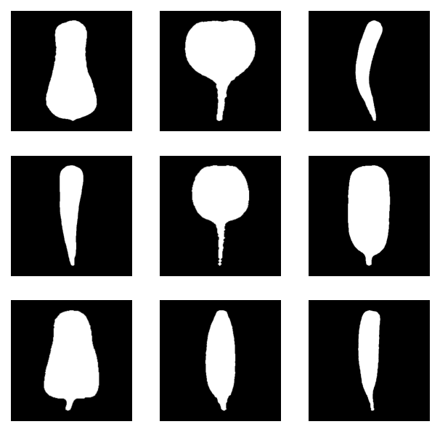

実験環境

AMD Ryzen 7 PRO 4750GE 3.10 GHz (8core)

RAM 16GB

Anaconda no GPU

## img 2 lr=0.001

**6次err_th 1.0, Samples=22 gap r=3 結果まとめ**

| **0** |  | **((0.9496184299803144, 0.866043018004294),**  **3.0625,**  **(6, 3),**  **([[152.0, 27.0],**  **[72.72073875124993, 31.544923914918613],**  **[110.20993237890673, 126.71950998269415],**  **[194.9934134467827, 128.93475457393018],**  **[-5.7610910251244425, 217.97578065890818],**  **[97.57369914166983, 277.79144248735884],**  **[149.0, 279.0]],**  **[[159.0, 26.0],**  **[224.93577336247407, 19.396975364561087],**  **[202.02209962544956, 166.81802805361855],**  **[84.11823694307797, 99.59462552822679],**  **[338.15907515624076, 252.68494552047005],**  **[199.61243990819617, 265.4979395624514],**  **[156.0, 281.0]]))** |
| --- | --- | --- |
| **1** |  | **((0.9056873925841198, 0.9730540015095259),**  **3.90625,**  **(5, 7),**  **([[146.0, 27.0],**  **[76.42975382086067, 38.5587056526155],**  **[60.53087097306783, -53.3885771402862],**  **[-56.51182408193289, 394.60165194838964],**  **[258.2661129167009, 0.2623590847422304],**  **[124.48103683927629, 252.4717186566494],**  **[147.0, 280.0]],**  **[[153.0, 28.0],**  **[212.1913710137604, 32.16747036657638],**  **[276.3094214818695, -51.63305555867579],**  **[319.4981168899111, 357.7238134605683],**  **[92.6258845938959, 26.51569321174803],**  **[189.9653343288021, 254.96869256070053],**  **[154.0, 280.0]]))** |
| **2** |  | **((0.6888606060791741, 0.8092795317166753),**  **2.453125,**  **(2, 2),**  **([[165.0, 26.0],**  **[117.48731936889698, 34.70198303601417],**  **[157.23897086721294, 143.0882747986064],**  **[68.65873106051278, 109.30015009123342],**  **[132.39097975648778, 225.12548315856293],**  **[140.8584162871064, 233.84989694914873],**  **[167.0, 281.0]],**  **[[172.0, 27.0],**  **[222.26866947821284, 47.103224124282235],**  **[137.83600555409856, 124.24132838066087],**  **[158.1425917598181, 111.44816650959896],**  **[135.5028035842722, 215.99470978588846],**  **[172.39659711341184, 224.8337654507575],**  **[171.0, 277.0]]))** |
| **3** |  | **((0.5474401978034666, 0.9201470251696463),**  **2.078125,**  **(1, 1),**  **([[150.0, 26.0],**  **[95.30589352631964, 25.887412689643696],**  **[151.9567003768096, 127.90425570530395],**  **[92.57762307079835, 137.95394640698115],**  **[149.28428740889154, 208.13928904704372],**  **[132.59978386028376, 231.23540755145842],**  **[154.0, 280.0]],**  **[[158.0, 26.0],**  **[204.99840107869122, 23.32178712192093],**  **[183.90708860613776, 134.83008021570828],**  **[150.69921376891133, 115.22440567933377],**  **[174.3773828936572, 189.49125568464893],**  **[164.43489821026907, 228.69759289982858],**  **[161.0, 279.0]]))** |
| **4** |  | **((0.9934081575284712, 0.9751928633872533),**  **10.421875,**  **(14, 36),**  **([[151.0, 27.0],**  **[105.9686678426819, 21.96714863926577],**  **[19.095123428280655, -1.647167494272329],**  **[68.54567620932804, 396.64036165642847],**  **[193.38636029595506, -36.0548859415794],**  **[142.56502006717037, 274.5734848588723],**  **[148.0, 279.0]],**  **[[159.0, 27.0],**  **[203.35808167500903, 12.087034953434094],**  **[312.04769717457174, 46.298280418470185],**  **[191.37257603218936, 416.2353586032419],**  **[131.6063650319807, -63.8686772868179],**  **[176.90188048121223, 266.15785432922456],**  **[154.0, 280.0]]))** |
| **5** |  | **((0.9234685524976748, 0.9877697542452382),**  **3.453125,**  **(5, 5),**  **([[150.0, 27.0],**  **[88.68939776134376, 20.801960763075915],**  **[77.36326936188969, 102.74534792817221],**  **[156.61868004430292, 121.32482389002904],**  **[25.869812939897756, 247.49465166589198],**  **[147.93786196544744, 217.2270311580222],**  **[150.0, 279.0]],**  **[[158.0, 27.0],**  **[206.048889678178, 9.294839705280879],**  **[262.03017196160965, 144.42919379612545],**  **[107.53116017620363, 72.75302071443672],**  **[299.2120852195113, 267.85417508901537],**  **[156.93113358931635, 221.5627025052547],**  **[156.0, 279.0]]))** |
| **6** |  | **((0.8960623255312551, 0.9992453486686094),**  **46.125,**  **(12, 254),**  **([[148.0, 26.0],**  **[81.9361450410076, 19.058435266321762],**  **[83.30178109057901, 192.5676183888175],**  **[218.9605405371384, -21.97008649964827],**  **[-96.61901265216873, 393.7506498895955],**  **[175.2932266339454, 183.17034955203113],**  **[138.0, 279.0]],**  **[[157.0, 26.0],**  **[263.7996739426899, 26.386055947606813],**  **[122.84612278295941, 230.68461080353893],**  **[293.1012936026075, -61.412916796869226],**  **[215.40719178746707, 472.1909793723258],**  **[222.29030299979541, 147.78452147876217],**  **[144.0, 281.0]]))** |
| **7** |  | **((0.756754379375018, 0.6480497810565599),**  **2.296875,**  **(2, 1),**  **([[154.0, 26.0],**  **[117.47997472253833, 36.97235305219308],**  **[122.8625400820268, 140.85948207578465],**  **[111.95226081866731, 92.20253752953886],**  **[96.43771581976121, 252.06001198985888],**  **[138.9716397608764, 227.6185981570688],**  **[161.0, 281.0]],**  **[[162.0, 26.0],**  **[184.37790652006228, 40.627447389904894],**  **[214.3910387263833, 119.17121091406604],**  **[148.93823394558126, 113.15806384245451],**  **[242.01380230274154, 236.90628416240313],**  **[162.47095809202193, 219.1984645119365],**  **[168.0, 279.0]]))** |
| **8** |  | **((0.3665077896037683, 0.7903853594276942),**  **2.234375,**  **(1, 2),**  **([[157.0, 26.0],**  **[107.31684009441541, 24.737496500709824],**  **[136.6634785505386, 145.41377541047217],**  **[123.51798088666834, 101.61974657364165],**  **[117.05974116258552, 231.68734074205628],**  **[150.77577269850954, 224.64420672350573],**  **[159.0, 280.0]],**  **[[163.0, 28.0],**  **[220.65557430792805, 31.135214212842154],**  **[117.27484293945325, 134.22102104505524],**  **[230.5559097621948, 128.3378269787332],**  **[161.2587925350336, 208.10203277637189],**  **[155.15463287303982, 228.41422870581306],**  **[166.0, 279.0]]))** |

**中心軸の推定**

**左右の平均線 1次近似**

**32点再サンプリングし、4次ベジエ曲線で近似**

|  |  |  |
| --- | --- | --- |
|  |  |  |
|  |  |  |
|  |  |  |

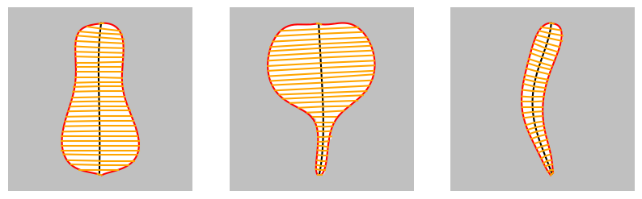

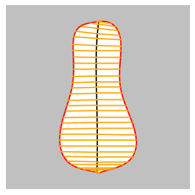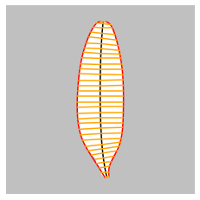

**左右の輪郭上に等間隔に３２点を取り対応する点を結んだ線分と中心線の交点を連立方程式を解いて求めることで中心線上に３２の標本点を定める。各標本点の垂線と左右輪郭の交点を求め、その間の距離を幅ｗと考える。（-w/2, y), (w/2,y)を標本点と考えて曲線当てはめをして得られる曲線が補正形状である**

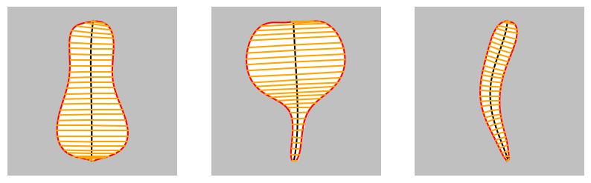

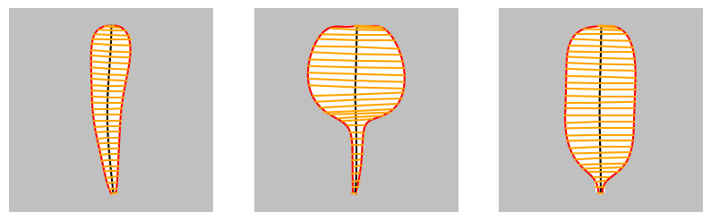

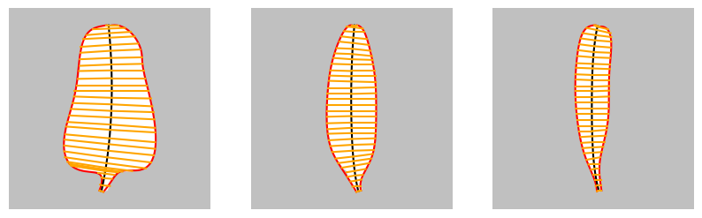

**形状補正**

**幅のサンプル数２２、６次近似 fitT1, err_th 1.0**

| **0** |  | **補正後の全長は 258.2 pixels**  **最大幅は 129.0 pixels** |
| --- | --- | --- |
| **1** |  | **補正後の全長は 263.5 pixels**  **最大幅は 177.3 pixels** |
| **2** |  | **補正後の全長は 293.3 pixels**  **最大幅は 42.4 pixels** |
| **3** |  | **補正後の全長は 262.7 pixels**  **最大幅は 59.1 pixels** |
| **4** |  | **補正後の全長は 257.8 pixels**  **最大幅は 144.1 pixels** |
| **5** |  | **補正後の全長は 254.8 pixels**  **最大幅は 106.0 pixels** |
| **6** |  | **補正後の全長は 265.1 pixels**  **最大幅は 138.6 pixels** |
| **7** |  | **補正後の全長は 263.9 pixels**  **最大幅は 75.0 pixels** |
| **8** |  | **補正後の全長は 265.3 pixels**  **最大幅は 52.0 pixels** |
|  |  |  |

**７次err_th 1.0, Samples=32 結果まとめ**

| **０** |  | ((0.9098056378705006, 0.6371690504052849),  4.515625,  (3, 2),  ([[152.0, 27.0],  [85.8004049654844, 31.89098375822191],  [100.36948013635312, 60.85881842376201],  [158.21482235921314, 225.25880984937618],  [98.48795118886635, 68.78397845127758],  [41.25790090274584, 282.6287024287265],  [95.49824107817165, 266.47979417122315],  [149.0, 279.0]],  [[159.0, 26.0],  [215.6436001065384, 26.919007533996567],  [206.01548535902637, 95.73810520991246],  [143.34130502293317, 191.38115470952204],  [183.07351058968885, 96.26459244535766],  [303.92636039802335, 292.3041148870559],  [190.44834822866758, 261.52014618918395],  [156.0, 281.0]])) |
| --- | --- | --- |
| **1** |  | ((0.9347018148002663, 0.9715960272206965),  6.03125,  (4, 5),  ([[146.0, 27.0],  [79.70965778451362, 39.04994437404342],  [75.5920609379749, -39.7845821162225],  [-15.697752524949397, 242.5986439661648],  [82.43209853515171, 180.88735264589857],  [220.2405009739459, 97.66210676350201],  [125.95547414737516, 251.48621810322564],  [147.0, 280.0]],  [[153.0, 28.0],  [214.52897686108037, 36.91594955933986],  [222.3621663860685, -64.1949166808921],  [348.44928863553, 271.9142999201703],  [192.77965635614635, 106.92006834904133],  [128.97631086954937, 157.02460664054604],  [183.28283204701427, 240.96633675905622],  [154.0, 280.0]])) |
| **2** |  | ((0.3710800314857454, 0.7184684084579339),  3.46875,  (1, 1),  ([[165.0, 26.0],  [123.34608496536163, 32.87944592593569],  [138.9305030553959, 125.45850718092083],  [126.23466223610687, 91.76612206240551],  [68.78622700696334, 201.9721475790905],  [155.34713272408476, 204.33589431785066],  [138.99205940546966, 246.37977825697968],  [167.0, 281.0]],  [[172.0, 27.0],  [217.7082969714737, 34.643374485739265],  [141.2378452545854, 134.25982639852697],  [191.35219808609315, 72.00080373529002],  [106.85015590353946, 186.5795211880618],  [169.07222244028713, 213.91881599464145],  [166.61331274219046, 230.3268394123145],  [171.0, 277.0]])) |
| **3** |  | ((0.2998914337117996, 0.7441197497215332),  3.5,  (1, 1),  ([[150.0, 26.0],  [100.09499144929484, 31.60149094435544],  [132.81520208437612, 82.726822225133],  [135.68541899146123, 167.4474369185478],  [93.86959637300278, 135.3397475782098],  [158.29041354759, 228.07501838563306],  [132.8765778760715, 237.70863139038727],  [154.0, 280.0]],  [[158.0, 26.0],  [198.1051299088978, 26.68041002900041],  [197.26441711626646, 92.65849942351741],  [145.24912259481508, 153.631453029716],  [181.91580640946458, 109.56601847626432],  [159.2905967703319, 227.46981534023226],  [166.86280077872215, 231.34560479613333],  [161.0, 279.0]])) |
| **4** |  | ((0.989116310500425, 0.9663702908886568),  12.375,  (11, 22),  ([[151.0, 27.0],  [71.02900781317376, 37.98012035030071],  [167.06113085119236, -52.028425275006406],  [-142.06957790604966, 313.0409967160309],  [292.1824701417846, 135.24475026362438],  [109.60499399621936, 102.00586161786237],  [154.92148529076954, 270.35938979952346],  [148.0, 279.0]],  [[159.0, 27.0],  [229.0974610226314, 36.69657434932951],  [148.25656400891435, -69.25041819485392],  [480.60296087843005, 420.51689680083774],  [-68.42822570335728, 47.50503441349505],  [258.37836442018016, 130.72044264422252],  [144.25272704927266, 268.10373413666645],  [154.0, 280.0]])) |
| **5** |  | ((0.9113386353574853, 0.9525875664787918),  3.578125,  (1, 1),  ([[150.0, 27.0],  [112.16047739575599, 22.958325907748993],  [35.47414480310025, 68.4661745541828],  [190.80548290949753, 157.26066602583106],  [41.97789440283051, 115.09495015443743],  [85.62798702371586, 272.0779017911519],  [147.5066308830149, 222.70339105818883],  [150.0, 279.0]],  [[158.0, 27.0],  [206.41891085298374, 20.428248960444392],  [221.70825131390632, 64.15823366684883],  [216.59687820399432, 182.26106892244897],  [145.54778847195624, 95.75426533496676],  [283.8656854259381, 278.74182603164513],  [149.9036465583836, 225.41753964324718],  [156.0, 279.0]])) |
| **6** |  | ((0.94370217467285, 0.9965374817944901),  11.0,  (3, 24),  ([[148.0, 26.0],  [94.54563168331627, 34.0965650925596],  [99.7719703225154, 36.01963813240929],  [109.26252476962362, 307.8604383589817],  [145.37773475441276, -79.42873347198733],  [-55.26163202877228, 445.5016289461956],  [179.8538445461571, 172.0529087106706],  [138.0, 279.0]],  [[157.0, 26.0],  [225.45351815966387, 17.54238422988186],  [237.4688649767064, 200.19915827000483],  [72.945880416956, -82.9368561108529],  [417.13731179727466, 341.504970220964],  [134.58646944450308, 298.0736756139768],  [205.7271642052468, 189.73671346588765],  [144.0, 281.0]])) |
| **7** |  | ((0.9175647276034908, 0.3050453378437994),  4.0,  (2, 1),  ([[154.0, 26.0],  [125.85255382236303, 26.87457979161683],  [112.6618951574996, 149.8167143789595],  [126.29196606285856, 43.309235893955744],  [103.77722792508455, 236.24761980356683],  [103.53950341318306, 199.55335527027168],  [144.94848317306673, 248.81698201994675],  [161.0, 281.0]],  [[162.0, 26.0],  [192.3934046839607, 30.112633757730357],  [166.23937178772084, 127.7355531272196],  [240.91304723075837, 82.11046791459057],  [131.37288723913161, 188.03900907785288],  [247.38521231681608, 231.1181019709848],  [156.4912626193076, 228.39664491974028],  [168.0, 279.0]])) |
| **8** |  | ((0.2926229057692542, 0.5543670256058364),  3.484375,  (1, 1),  ([[157.0, 26.0],  [108.05988651753565, 24.1992594250077],  [154.36584729760034, 117.60657951164774],  [85.88123858188013, 104.37910893944785],  [160.6906706767059, 179.6060629199862],  [105.30492621458728, 215.22966802383837],  [157.59312813812457, 235.9517640603019],  [159.0, 280.0]],  [[163.0, 28.0],  [205.48301627304994, 22.1736500815213],  [169.04254565857528, 138.731700327025],  [149.18356876613592, 73.98851424155865],  [229.90250895258828, 218.65057865123276],  [141.53983823295601, 181.6636506328186],  [162.08386291448673, 245.66061240174193],  [166.0, 279.0]])) |

## fitT1

## rd0

| 3 |  | ((33.61164510082403, 48.6095515876373),  32.0s,  (265, 240),  ([[154.0, 27.0],  [125.85064078860877, -31.594108377995006],  [38.16404127378264, 319.6690789644979],  [151.0, 279.0]],  [[157.0, 26.0],  [169.6464845277597, -32.2633590049885],  [271.15478186057123, 320.5132074389504],  [154.0, 280.0]])) |
| --- | --- | --- |
| 4 |  | ((0.49668074636758824, 0.49711326471181116),  24.734375s,  (140, 93),  ([[154.0, 27.0],  [32.83936920798376, 43.122347100387564],  [235.4833741371077, 111.73963567913006],  [-24.226132575828025, 252.98995850447417],  [151.0, 279.0]],  [[157.0, 26.0],  [267.4990844834438, 41.353710521343906],  [61.580147224012975, 154.95933317019055],  [340.2969182679209, 240.12232643671547],  [154.0, 280.0]])) |
| 5 |  | ((0.49697905573902357, 0.4924863510026046),  4.375,  (8, 10),  ([[154.0, 27.0],  [36.820560621934774, 34.05030761773013],  [211.94230374421616, 143.9484938337196],  [47.3581716845332, 176.78305417392633],  [54.55524265535238, 272.6920727360837],  [151.0, 279.0]],  [[157.0, 26.0],  [273.2900000372532, 45.940243275248115],  [62.12107158061507, 130.0704972166173],  [289.9540021248442, 214.4580810497768],  [240.12513781903164, 265.56111456194657],  [154.0, 280.0]])) |
|  |  | ((0.4886699492306217, 0.46482398654098567),  5.84375,  (10, 7),  ([[154.0, 27.0],  [59.57324823863286, 30.92147885697553],  [142.10293543388468, 118.30507670787426],  [150.8235183036316, 137.82133641734725],  [28.222560596326847, 218.69778275449167],  [83.4652049296137, 276.84205828013756],  [151.0, 279.0]],  [[157.0, 26.0],  [228.28920678432027, 21.24551300146109],  [202.62031425368244, 162.8459939623358],  [77.3142159672841, 97.36030096283991],  [349.8391474633886, 257.64130051536387],  [191.80275711133638, 270.5669236832109],  [154.0, 280.0]])) |

## rd1

| 4 |  | ((2.076649482713184, 2.0298458446971344),  50.046875s,  (212, 267),  ([[148.0, 27.0],  [-36.43487553888242, 4.387739380443991],  [118.05301958643506, 329.67756250017953],  [146.54168067758533, 41.740971989841746],  [149.0, 281.0]],  [[151.0, 28.0],  [345.25484186865907, -7.954288297432792],  [176.85582538802737, 321.03248859941493],  [205.49290633736874, 37.917934430209876],  [153.0, 280.0]])) |
| --- | --- | --- |
| 5 |  | ((1.12156300071975, 0.792704532766406),  706.78125s,  (1681, 2981),  ([[148.0, 27.0],  [-35.52315989294961, -3.356496651386881],  [91.15995503778997, 367.0636724248741],  [196.3384264725776, 13.094511844815024],  [130.65437063264645, 258.18840329550846],  [149.0, 281.0]],  [[151.0, 28.0],  [340.31531433694244, -15.368513125067619],  [211.60504071648518, 345.13677122944387],  [150.19149648951495, 27.1762495939466],  [179.2114717782623, 254.00384061868627],  [153.0, 280.0]])) |
| 6 |  | ((0.49579383325090337, 0.49967024376667224),  14.203125,  (13, 43),  ([[148.0, 27.0],  [74.08894075730889, 41.377638210353474],  [60.797714931143496, -73.43616126348833],  [-55.62185383894711, 443.00576229532277],  [264.08440203812813, -42.93012472572366],  [117.9935219024838, 270.1510088327996],  [149.0, 281.0]],  [[151.0, 28.0],  [202.31824297957465, 33.17927367381678],  [300.47539441974567, -69.32491116591133],  [286.22689853811215, 406.8126325579321],  [118.11586302116191, -18.203551413784137],  [185.57359589150815, 260.24410920373566],  [153.0, 280.0]])) |

## rd2

| 4 |  | ((0.6366912749588101, 0.5651855835371603),  513.96875s,  (3001, 1998),  ([[167.0, 26.0],  [128.34888536969407, 20.847214333933163],  [128.01972735962022, 164.05555845361474],  [83.71858342454212, 147.91955848594625],  [169.0, 281.0]],  [[171.0, 27.0],  [232.7739851552072, 48.40301358836834],  [95.45120892010742, 143.4314080171081],  [169.63153969429916, 203.63096155825448],  [171.0, 278.0]])) |
| --- | --- | --- |
| 5 |  | ((0.4679022989508819, 0.497684258087661),  6.015625s,  (8, 21),  ([[167.0, 26.0],  [119.69442475029575, 23.240381768451552],  [131.46805432598157, 204.5213265051738],  [79.73612895425417, 113.45114635335182],  [150.57927630732033, 263.3340347026735],  [169.0, 281.0]],  [[171.0, 27.0],  [229.01135598888067, 50.22873099963551],  [119.31533518574206, 116.58611416585136],  [146.04300340831003, 196.63288957927494],  [166.32414371241714, 213.60320522223367],  [171.0, 278.0]])) |
|  |  |  |
| 6 |  | ((0.4863490419661082, 0.47837342452349224),  6.046875s,  (6, 12),  ([[167.0, 26.0],  [111.66660245338585, 34.33229331268871],  [168.77565677526837, 134.2059676028587],  [51.51922039320447, 141.01669689728817],  [144.42465880799622, 197.2781709069411],  [139.42272520430606, 251.0468161224432],  [169.0, 281.0]],  [[171.0, 27.0],  [224.34584919112146, 54.50937837042557],  [140.27678590963026, 81.36303191392327],  [153.114172703812, 178.81256174156977],  [138.4720448532025, 174.62304957649783],  [171.70609236467982, 236.93145262726506],  [171.0, 278.0]])) |

## rd3

| 4 |  | ((1.0148538755914274, 0.4959468792926547),  76.828125s,  (736, 15),  ([[152.0, 26.0],  [100.85162886449957, 16.502662790654618],  [125.29405898117136, 154.4072291285532],  [137.44346008921985, 255.70874811168457],  [156.0, 281.0]],  [[156.0, 26.0],  [230.58773240063306, 32.96137443174276],  [126.96992252640345, 181.03595838709117],  [181.75451457621335, 192.58565607279206],  [159.0, 280.0]])) |
| --- | --- | --- |
| 5 |  | ((0.5037869323094343, 0.4695746804196947),  456.265625s,  (3001, 3),  ([[152.0, 26.0],  [88.34920887400679, 27.371145317467317],  [160.90341740958584, 135.7156649645112],  [89.55808122284694, 68.16697356018001],  [143.97759753826074, 266.0719071882214],  [156.0, 281.0]],  [[156.0, 26.0],  [223.37675160361707, 28.681341896950148],  [149.87321023161675, 155.3909825742395],  [167.05331241700338, 137.3574873163107],  [169.97614206665966, 233.31628250455068],  [159.0, 280.0]])) |
| 6 |  | ((0.43359603243850586, 0.4580456376121378),  3.34375,  (1, 4),  ([[152.0, 26.0],  [84.90942978751178, 25.619299414997982],  [172.25564538417336, 129.72372242975462],  [70.2714259124052, 139.0400882198579],  [164.5107165081609, 205.32882160597777],  [127.57038897352413, 238.55539767314053],  [156.0, 281.0]],  [[156.0, 26.0],  [213.9427625950866, 28.58921201540536],  [169.28420072354012, 116.52064778113218],  [165.1314931107896, 139.29834092577238],  [163.82692564180388, 172.84098841189473],  [169.2633695566849, 241.579223916651],  [159.0, 280.0]])) |

## rd4

| 4 |  | ((0.49446354662408787, 2.500070078832139),  24.015625s,  (64, 150),  ([[153.0, 27.0],  [9.954663164103613, -1.0003598387318915],  [106.0372820648245, 328.67442954700044],  [151.59653919199087, 31.22748423810582],  [150.0, 280.0]],  [[157.0, 27.0],  [307.254036794831, 5.485648961513247],  [175.6311045596604, 360.417604192277],  [184.41855689292566, -0.3461046342499875],  [153.0, 281.0]])) |
| --- | --- | --- |
| 5 |  | ((0.4929888274876747, 0.7102464961326721),  113.34375s,  (87, 651),  ([[153.0, 27.0],  [44.31379797848537, -2.527937144473469],  [41.68769964788437, 232.21717060222053],  [168.37509373447412, 175.92568621903357],  [142.9548149600813, 111.93525085484517],  [150.0, 280.0]],  [[157.0, 27.0],  [273.63869793351006, -6.434935345951341],  [259.44049475575184, 315.3083729707919],  [112.51848872323632, 101.9161848955079],  [187.5200077458218, 140.74057239141536],  [153.0, 281.0]])) |
| 6 |  | ((0.4844625890170057, 0.5547875759178517),  644.078125s,  (24, 3001),  ([[153.0, 27.0],  [109.179144893945, 26.81308124009868],  [7.986052852131416, -28.86223363643974],  [85.01690742526756, 456.8203815542476],  [188.13529884236934, -80.60453334746911],  [139.51197590263038, 283.3104197170636],  [150.0, 280.0]],  [[157.0, 27.0],  [260.2834422998569, 8.803650560067279],  [197.10388695651727, 145.16673598568312],  [314.17147058907057, 178.3048171041584],  [83.1583839631003, 197.95926063296452],  [195.6916497607021, 95.43360057638814],  [153.0, 281.0]])) |
| 7 |  | ((0.49529878024587354, 0.5351929741628454),  865.453125,  (32, 3001),  ([[153.0, 27.0],  [91.79411149621073, 34.11865769726255],  [119.20247513383775, -45.87017349767156],  [-89.63536558629447, 303.09774135492336],  [267.34866231188187, 166.76755017342623],  [116.38820180472923, 78.1279682750516],  [151.74643633897716, 265.61467778052435],  [150.0, 280.0]],  [[157.0, 27.0],  [211.88655985970578, 26.1061204163813],  [230.48082427492903, -26.67389620267643],  [346.88197663087016, 407.1321564670776],  [37.5157875288076, 36.35489255142046],  [206.0035945572075, 167.49849104941705],  [163.17612836575816, 210.89275606302778],  [153.0, 281.0]])) |

## rd5

| 4 |  | ((2.293532874632524, 1.3910604351399845),  234.953125s,  (1234, 974),  ([[152.0, 27.0],  [41.811936653299426, -1.2791465848628116],  [136.40005179788656, 384.07212893771595],  [100.38167496082751, 158.3205932702775],  [152.0, 280.0]],  [[156.0, 27.0],  [264.7171746431591, -9.691182502147704],  [164.00572918036002, 408.63860135381714],  [202.60329216355666, 169.3214301112088],  [154.0, 280.0]])) |
| --- | --- | --- |
| 5 |  | ((0.7197131566311554, 0.5902283971168494),  515.75,  (367, 3001),  ([[152.0, 27.0],  [67.9534262170475, 38.556629379184756],  [128.29789603245086, 32.415245175907714],  [68.0478467582257, 329.47116320714804],  [119.50256038232251, 176.96308328636994],  [152.0, 280.0]],  [[156.0, 27.0],  [230.4465720750063, 25.507970312712757],  [196.75293087437, 54.18912562540496],  [216.89415163992018, 363.44638628175136],  [182.8072346445696, 186.54141078123854],  [154.0, 280.0]])) |
| 6 |  | ((0.6132190034387527, 0.4996513267402855),  652.9375,  (3001, 49),  ([[152.0, 27.0],  [51.359382474921674, 33.71581455766366],  [157.6498218150122, 112.07086043159553],  [50.9898689732259, 66.97081630751482],  [113.07195984411017, 346.6288403924027],  [115.66613556969419, 174.54084918126557],  [152.0, 280.0]],  [[156.0, 27.0],  [230.22565629528134, 12.268987144427177],  [200.28841969148667, 157.43766542851768],  [194.36725159936057, -2.5397082508598703],  [227.96534521584869, 372.3913258931211],  [182.2808357831994, 184.641911967351],  [154.0, 280.0]])) |
| 7 |  | ((0.4999762012595662, 0.4950852699284258),  25.03125s,  (63, 15),  ([[152.0, 27.0],  [112.16895638637172, 31.34440471299992],  [28.440193935976808, 28.75762190658195],  [222.45854892436165, 228.80213523723458],  [-24.98415714618035, 12.524125408255033],  [162.6794339802617, 391.05007232080203],  [108.36294151746705, 165.38820817120143],  [152.0, 280.0]],  [[156.0, 27.0],  [198.5414577911589, 21.43872811676117],  [248.7482192995035, 38.121940713049845],  [158.14377724632465, 255.8365363577684],  [226.7564596289946, -12.31932165332409],  [215.5837841454428, 378.87703703325604],  [177.3377591148665, 188.6290347645372],  [154.0, 280.0]])) |
| 8 |  |  |

## rd6

| 4 |  | ((10.759120348955518, 3.7403362521514842),  110.78125,  (846, 224),  ([[151.0, 26.0],  [154.05961126072435, -161.5975418050269],  [-13.209571658503984, 493.3834714995032],  [139.63040637393965, 150.69603111982056],  [140.0, 279.0]],  [[155.0, 26.0],  [234.87272393612113, -12.593838792499161],  [238.28367975980942, 420.9277565717873],  [220.8883270994696, 164.12046231303955],  [143.0, 280.0]])) |
| --- | --- | --- |
| 5 |  | ((1.0998578658590668, 2.4173718234644643),  146.625,  (424, 529),  ([[151.0, 26.0],  [33.712583490570076, 51.92324442368136],  [246.87103731442042, 44.4330648226481],  [-92.42239143197335, 376.8959306919682],  [168.4042470205056, 183.77663719060388],  [140.0, 279.0]],  [[155.0, 26.0],  [222.54626073580306, 33.98278216972726],  [169.68725613672967, 10.014992952377966],  [293.8976065152084, 412.35343255789684],  [203.70410175256674, 168.01258943478993],  [143.0, 280.0]])) |
| 6 |  | ((0.4883280793518234, 1.4710833719896985),  170.09375,  (15, 745),  ([[151.0, 26.0],  [62.97803266950952, 21.789902310847527],  [127.37214122250374, 195.55196148472388],  [164.31250996797056, -44.64511325505906],  [-55.5542311671446, 431.7186197063016],  [160.24827791284446, 169.02346402459037],  [140.0, 279.0]],  [[155.0, 26.0],  [272.66227315083023, 24.641631978332526],  [110.16986475121622, 263.78086410233436],  [307.1672335291121, -104.62156122161986],  [202.62244562027354, 488.4017493198464],  [230.146267675838, 146.42562935848056],  [143.0, 280.0]])) |
| 7 |  | ((0.49810126199710186, 0.4998775491875501),  90.40625s,  (19, 289),  ([[151.0, 26.0],  [88.51767376159223, 29.50047809924938],  [85.23136982434303, 75.08994912735018],  [173.1941067992047, 205.0759704470062],  [51.077602237725046, 15.607403391112065],  [17.642896451889538, 426.7731872697095],  [152.3856568049842, 167.70295237786578],  [140.0, 279.0]],  [[155.0, 26.0],  [245.14170095397046, 10.293984047613447],  [222.0519871162448, 327.7164901116128],  [36.573771889516, -437.6645297425134],  [508.65974900253957, 796.1788436285198],  [63.305502204083545, 23.02253056413469],  [189.35466651847622, 281.59049534781764],  [143.0, 280.0]])) |
| 8 |  |  |

## rd7

| 4 |  | ((1.1515676342913357, 0.4996343423544741),  44.765625s,  (55, 352),  ([[156.0, 26.0],  [115.4391526352242, 21.9317670246073],  [106.57275295594852, 223.804598615714],  [106.81320182485868, 198.63412309480387],  [163.0, 281.0]],  [[160.0, 26.0],  [194.86094301060274, 14.472108189417948],  [208.55618220131907, 272.99730705547256],  [177.67219345380192, 206.45005365728667],  [166.0, 280.0]])) |
| --- | --- | --- |
| 5 |  | ((0.9547038516541954, 0.49972446746634835),  158.734375,  (891, 103),  ([[156.0, 26.0],  [130.65042907966895, 15.928047335611025],  [84.5385675391065, 163.62212442525302],  [143.26459592282302, 231.66850935789188],  [90.97064863311923, 180.10104051641235],  [163.0, 281.0]],  [[160.0, 26.0],  [189.00185313936362, 32.01110099740634],  [190.10909263534506, 93.76258773224207],  [207.78953650980299, 269.94586880652633],  [177.99827624033068, 202.52867983677893],  [166.0, 280.0]])) |
| 6 |  | ((0.9592020040967977, 0.4841743369602641),  165.734375,  (757, 4),  ([[156.0, 26.0],  [133.77725201877857, 17.739435277483246],  [100.07597572671665, 118.53984286106716],  [113.47897429717031, 200.8443008471487],  [125.8062725897149, 215.59806922841156],  [105.07709367134409, 199.73182677560746],  [163.0, 281.0]],  [[160.0, 26.0],  [188.63322901663895, 27.32555998003989],  [202.334925406025, 153.7422165113955],  [167.45927216194406, 82.34810138817232],  [228.10189746500066, 255.23146323937647],  [165.45641510473286, 224.9138479659997],  [166.0, 280.0]])) |
| 7 |  | ((0.49879452001041924, 0.43316016043761757),  11.5625,  (30, 1),  ([[156.0, 26.0],  [123.48660493891553, 7.525364681787106],  [106.67324472241083, 255.3132905831244],  [144.94107176574633, -177.22864219725088],  [80.74703793798344, 458.01055747494155],  [122.8244969633095, 96.97401975671237],  [137.11168790706023, 271.5629146283014],  [163.0, 281.0]],  [[160.0, 26.0],  [187.96316483208736, 23.912982401251124],  [183.37868310916875, 135.31927416450046],  [210.72313596993683, 60.845174402567736],  [162.9975990328833, 225.85906235586273],  [228.6050964170367, 200.36874245958938],  [160.9216788172697, 245.592504035802],  [166.0, 280.0]])) |

## rd8

| 4 |  | ((0.49827044889044575, 2.0694330930420906),  137.640625,  (13, 1321),  ([[159.0, 26.0],  [101.95500072423918, 19.130584525502584],  [134.261488718735, 224.87176903352517],  [127.05399331060305, 187.7009344775463],  [161.0, 281.0]],  [[162.0, 27.0],  [205.40197577293392, -4.760732825639714],  [162.19387293618888, 335.0405020169606],  [159.92329140490574, 172.4542411100469],  [164.0, 280.0]])) |
| --- | --- | --- |
| 5 |  | ((0.4323723716917827, 0.4991129901222361),  22.0625,  (5, 130),  ([[159.0, 26.0],  [97.7109560198162, 25.03766121248838],  [154.25273840599317, 170.83339475056908],  [96.80343635548641, 147.8022176375315],  [149.61655503927958, 239.6960591648168],  [161.0, 281.0]],  [[162.0, 27.0],  [213.10065792230185, 34.155826815078534],  [139.59888063494628, 68.18645838308711],  [209.17731498723856, 314.28194342829954],  [151.7810122859956, 134.40679453746537],  [164.0, 280.0]])) |
| 6 |  | ((0.38527467017670786, 0.49629058267011567),  9.84375,  (1, 35),  ([[159.0, 26.0],  [104.77990160776002, 21.688425949345753],  [144.3928587016588, 149.4111090091327],  [111.1830088194735, 110.54097723313122],  [127.01715147988935, 219.13133484542087],  [146.3898602675036, 231.26584714024523],  [161.0, 281.0]],  [[162.0, 27.0],  [227.26168753484936, 35.46647178302349],  [102.2388864922255, 129.66100373732164],  [254.30007641315504, 113.9699821871279],  [137.38417798240755, 244.80516389225278],  [164.15340898496564, 217.06182114873437],  [164.0, 280.0]])) |